

# Movie Booking System

**PROJECT REPORT**

Submitted for CAL in B.tech Engineering Internet and Web Programming CSE3002

By

**PUNEET JAIN**

**(15BCE1351)**

Slot: G1

**Name of faculty**: **Dr. R. NANDHINI**

**(SCHOOL OF COMPUTING SCIENCES AND ENGINEERING)**

November, 2016

**CERTIFICATE**

This is to certify that the Project work entitled “Movie booking system” that is being submitted by “***PUNEET JAIN***” for CAL in BTech Engineering CSE3002 is a record of bonafide work done under my supervision. The contents of this Project work, in full or in parts, have neither been taken from any other source nor have been submitted for any other CAL course.

Place : VIT Chennai

Date : 9th November

**Signature of Students**:

**PUNEET JAIN**

**Signature of Faculty:**

**Dr. R. NANDHINI**

**ACKNOWLEDGEMENTS**

We would like to thank our faculty Dr. R. NANDHINI

for her constant support and guidelines throughout the project.

We would also like to thank our school, SCSE for this wonderful opportunity ..

**ABSTRACT**

This project is aimed at developing an online ticket reservation system for a Cinema

Hall. The Ticket Reservation System is an Internet based application that can be

accessed throughout the Net and can be accessed by anyone who has a net connection.

This application will automate the reservation of tickets.

1. **Introduction:**

**The main purpose of our online ticket booking system is to provide an alternate and convenient way for a customer to buy cinema tickets. It is an automatic system. After the data has been fed into the database, the staff does not need to do anything with the order once it is received through the system. In fact, there is similar system on the internet, but there is no refund method found in the existing system.**

**2. Methodology:**

The methodology applied in our project is the use frontend HTML , CSS and use of make the database and connect it to website which is done by php. Databases are implemented incrementally until we delivered the final project .To make the backend we have used xampp. **XAMPP** is a free and open source cross-platform local web server.

3.home page

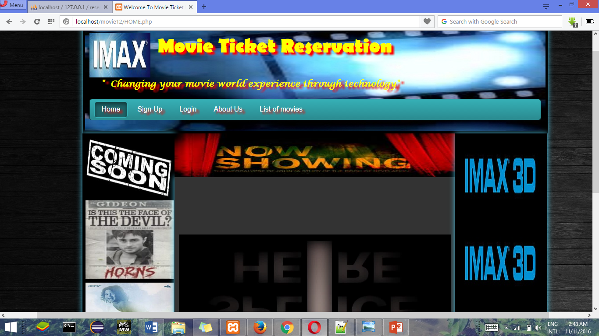

4. signup page

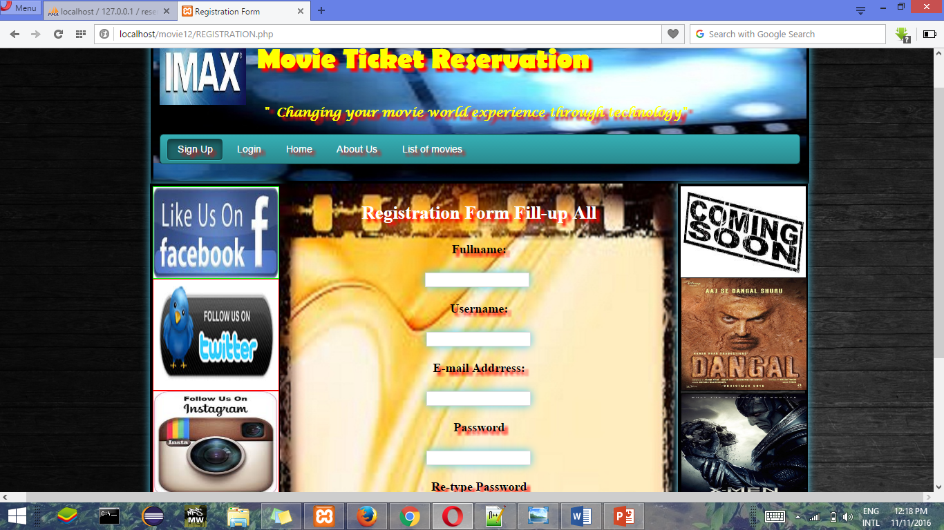

5. login page

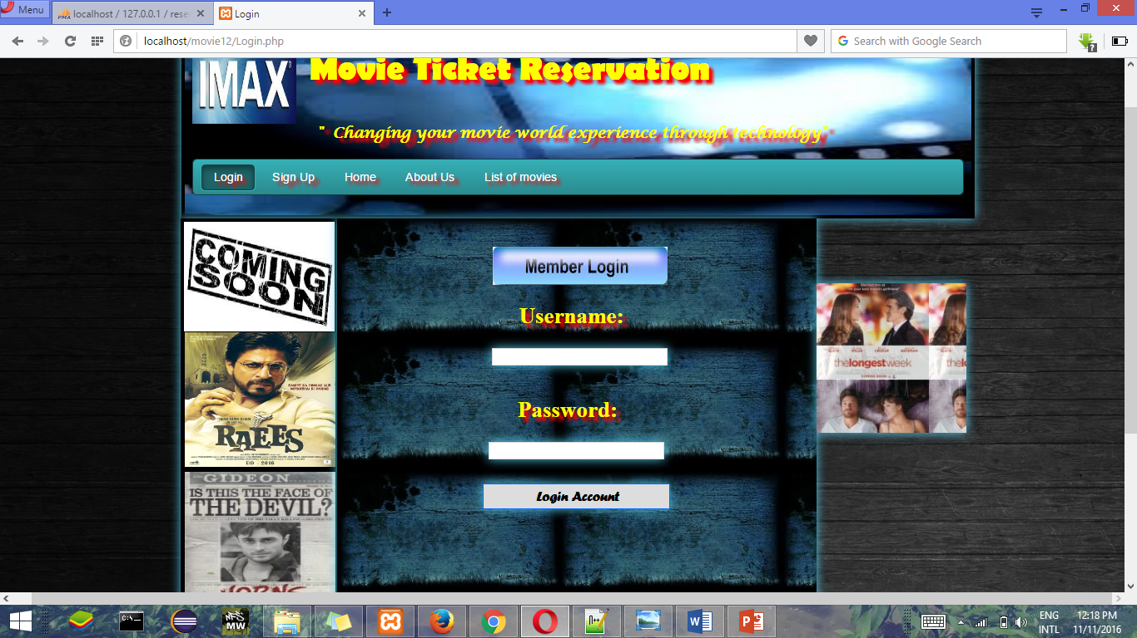

6. About us page

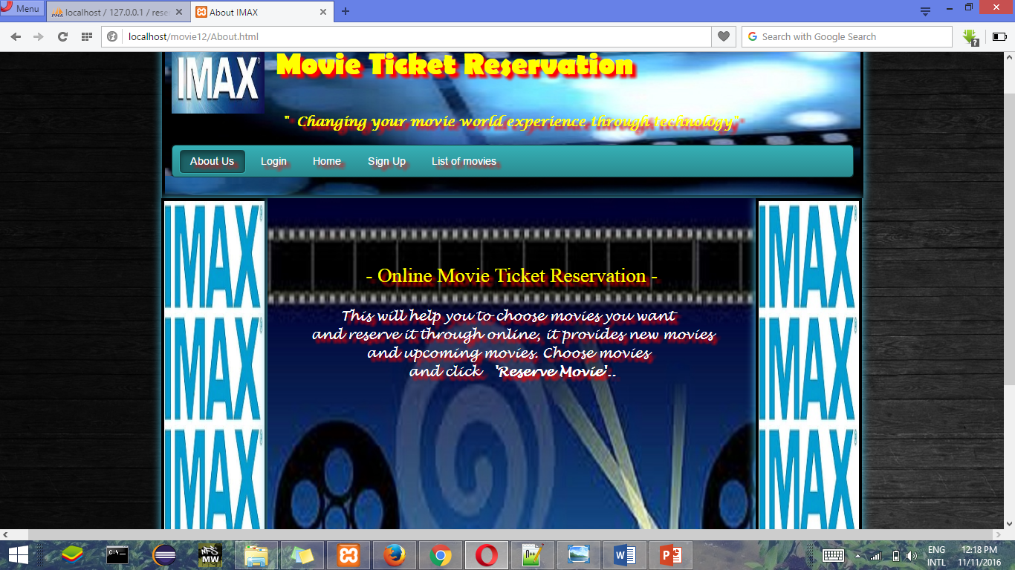

7. list of movies

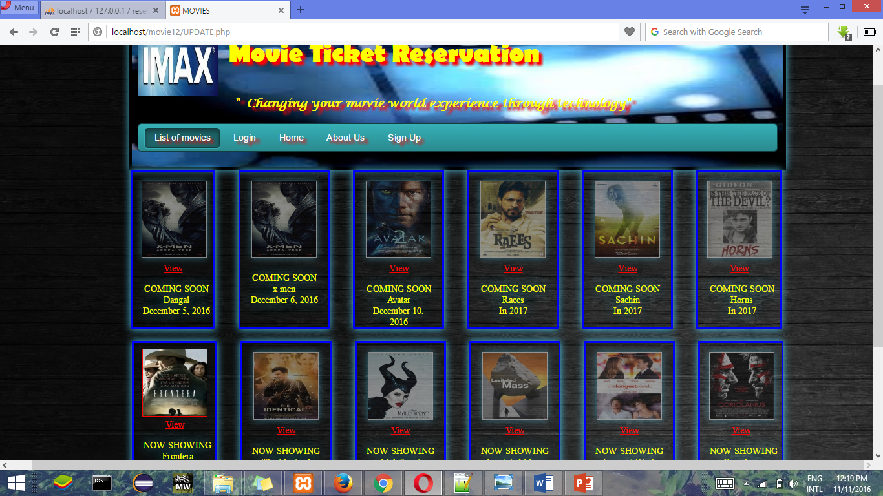

**8. Future Prospects**

More features can be added like

1. Allow customers to comment on movies.
2. SMS notification after successful seat reservation.

3. Home delivery of ticket may be provided.

4. Online booking of purchases of eatables( cold drinks, popcorn etc ) can be provided.

**9. Conclusion**

Use of this interface help customer having immediate information about running movies and reserve their seat without wasting their precious time.

User friendly interface also for the admin to add and delete movie information.

**10**. **References**

tutorialspoint.com

w3school.com